Roger W. Lidman, M.D., F.A.C.P.
Witold A. Turkiewicz, M.D.
John V. Mansoor, M.D.
Julianne S. Orlowski, D.O.
Megan E. Eshbaugh, D.O., F.A.C.O.I.

____________________________________
Welcome to the Center for Arthritis and Rheumatic Diseases, P.C.
This is to confirm your appointment with Dr. __________________________ at ___________ AM/ PM on _______________________________________ in our _____________________________________ office.
Directions to each office are attached for your convenience. To ensure all forms are completed and ready for your physician’s review, please arrive at least 30 minutes early.
When you come in, it is very important to bring the attached PATIENT HISTORY FORM completed, with any x-ray films, blood test results, or other results, your insurance card(s), photo ID, and the referring doctor’s full name and address. These are very important for your medical record.
Please note, our practice does not perform pain management. Our providers will evaluate for any rheumatologic diseases and will work closely with your primary care physician. Center for Arthritis takes pride in the importance that we place on being part of a health care team. We require that patients have seen their primary care provider within one year of their appointment at our office.
You may be contacted by our billing department prior to your visit to verify your insurance coverage. We file your insurance for you, and a patient account representative will be assigned to you to help with your billing needs. Since your insurance company may not cover the entire cost of your visit, we do require payment at the time of service. If any of your insurance information changes, please contact our billing office at (757) 461-6997.
We will try to call you two days in advance of this appointment to confirm, and we must hear back from you within 24 hours of your appointment. Regardless of whether we are able to reach you to confirm, it is your responsibility to contact us to confirm this appointment; otherwise, your appointment will be cancelled and given to another new patient. You must speak directly with the front desk to confirm your initial appointment. Do not leave a message as confirmation. A $150.00 charge will be added to your account for failure to keep your new patient confirmed appointment.
We appreciate your cooperation and look forward to your visit. If you have any questions, please contact the office where your appointment is scheduled; the numbers are listed below.

Thank You,

The Center for Arthritis & Rheumatic Diseases, P.C.

PATIENT HISTORY FORM
Name: _____________________________________________________________ Birthday: _____ / _____ / ________
Nickname/ Name you go by: _____________________________ Birth Place: _________________________________
Social Security #: _______________________________ Marital Status: Single Married Divorced Widowed
Address: _____________________________________________ Race: _________________________________
____________________________________________________ Age: __________________ Sex: M/ F
Home Phone: ____________________________ Cell Phone: _____________________________
Pharmacy Name: ____________________________________________ Phone Number: __________________________
Employer: __________________________________________________ Work Phone: ________________________
Primary Insurance: __________________________________________ Policy # ________________________________
Subscriber: _____________________Subscriber DOB: ______________ Subscriber Social Security # _________________
Secondary Insurance: _________________________________________ Policy # ________________________________
Subscriber: _____________________ Subscriber DOB: ______________ Subscriber Social Security # ________________
Additional Insurance: _________________________________________ Policy # ________________________________
Subscriber: _____________________ Subscriber DOB: _______________Subscriber Social Security # _______________
Next of Kin: _________________________________________________ Relationship: ___________________________
Emergency contact #: _______________________ Name: __________________________ Relationship: _____________
Who referred you to us? ______________________________________________________________________________
The name of the physician providing your primary medical care: ______________________________________________
Do you have an orthopedic surgeon? ____ Y/ ___ N If yes, Name: _________________________________________
Main symptoms and Reasons for coming to see the doctor: ____________________________________________________________________________________________________________________________________________________________________________________________________
Date symptoms began (approximately): _______________________________ Diagnosis: _________________________
Please list the names of other practitioners you have seen for this problem: ____________________________________________________________________________________________________________________________________________________________________________________________________
I AFFIRM THAT THE INFORMATION ABOVE IS ACCURATE AND TRUE. I UNDERSTAND THAT I AM FINANCIALLY RESPONSIBLE FOR ALL SERVICES INCURRED FOR THE ABOVE NAMED PATIENT. I AGREE TO PAY ANY COSTS OF COLLECTIONS IF NECESSARY. I AUTHORIZE TREATMENT FOR THE ABOVE NAMED PATIENT, RELEASE OF MEDICAL INFORMATION AND ASSIGNMENT OF BENEFITS PAID TO THE PRACTICE.
Signature of Patient/ Responsible Party: ________________________________________ Date: ___________________
Past Medical History (Please circle)
Arthritis (unknown type) Cancer, if so type _________ Glaucoma Goiter/Thyroid Dysfunction
Osteoarthritis Seizures Lung Disease Kidney Disease
Gout Stroke Emphysema/ Asthma Rheumatic Fever
Childhood Arthritis High Blood Pressure Crohns/Ulcerative Colitis HIV
Lupus or “SLE” Heart Attack/ MI Stomach Ulcers Hepatitis
Rheumatoid Arthritis Congestive Heart Failure (CHF) GERD/ Acid Reflex Tuberculosis
Ankylosing Spondylitis A-fib/ Arrhythmia Anemia Anxiety/ Depression
Osteoporosis Cataracts Diabetes Psoriasis
Additional Medical Conditions: ____________________________________________________________________________________________________________________________________________________________________________________________________________________________________________________________________________________________________________________________________
PREVIOUS OPERATIONS:
TYPE | YEAR | REASON
1.
2.
3.
4.
5.
6.

Any previous Fractures? No Yes Describe: ________________________________________________________________
Any other serious injuries? No Yes Describe: ________________________________________________________________
FAMILY HISTORY:
IF LIVING IF DECEASED
 | AGE | HEALTH | AGE AT DEATH | CAUSE
FATHER
MOTHER

Number of siblings: __________ Number of living: _________ Number of Deceased: __________
Number of Children/Age: __________ Number of Living: __________ Number of Deceased: __________
Family History of (Please Circle):
Rheumatoid Arthritis Sjogrens Syndrome Osteoarthritis
Lupus “SLE” Thyroid Disease Gout
Anklosing Spondylitis Arthritis (unknown Type) Osteoporosis

SOCIAL HISTORY:
Do you drink caffeinated beverages? No Yes Cups/ Glasses per day? _______________
Do you smoke? No Yes Past- How long ago? _________________
Do you drink alcohol? No Yes Number per week? __________________
Has anyone told you to cut down on your drinking? No Yes
Do you use drugs for reasons that are not medical? No Yes If yes, please list: _________________________
Do you exercise regularly? No Yes Type:_________________________ Amount per week: ______________
How many hours of sleep do you get a night? _________________ Do you get enough sleep at night? No Yes
Do you wake up feeling tired? No Yes
Do you have an advanced Directive? No Yes
EDUCATION: (circle highest level attended)
Grade School 7 8 9 10 11 12 College 1 2 3 4 Graduate School Disabled Retired
Occupation _______________________________________________ # of hours worked per week __________________
MEDICATIONS:
Drug Allergies: Yes No To what: ________________________________________________________________
Type of reaction: ____________________________________________________________________________________

PRESENT MEDICAITONS: (List any medications you are taking. Include such items as aspirin, vitamins, laxatives, calcium and other supplements)
NAME OF DRUG | DOSE  (Include strength & # of pills) | HOW LONG HAVE YOU TAKEN THIS MEDICATION? | HAS THE MEDICATION HELPED?  (A lot/ Some/Not at all)
1.
2.
3.
4.
5.
6.
7.
8.
9.
10.
SYSTEMS REVIEW
Last Mammogram____________ Last Pelvic Exam_____________ Last Colonoscopy______________
Last Eye Exam_______________ Last Chest X-Ray_____________ Last Bone Density _____________
Last TB ____________________ Shingles Vaccine _____________ Pneumoccocal Vaccine _________

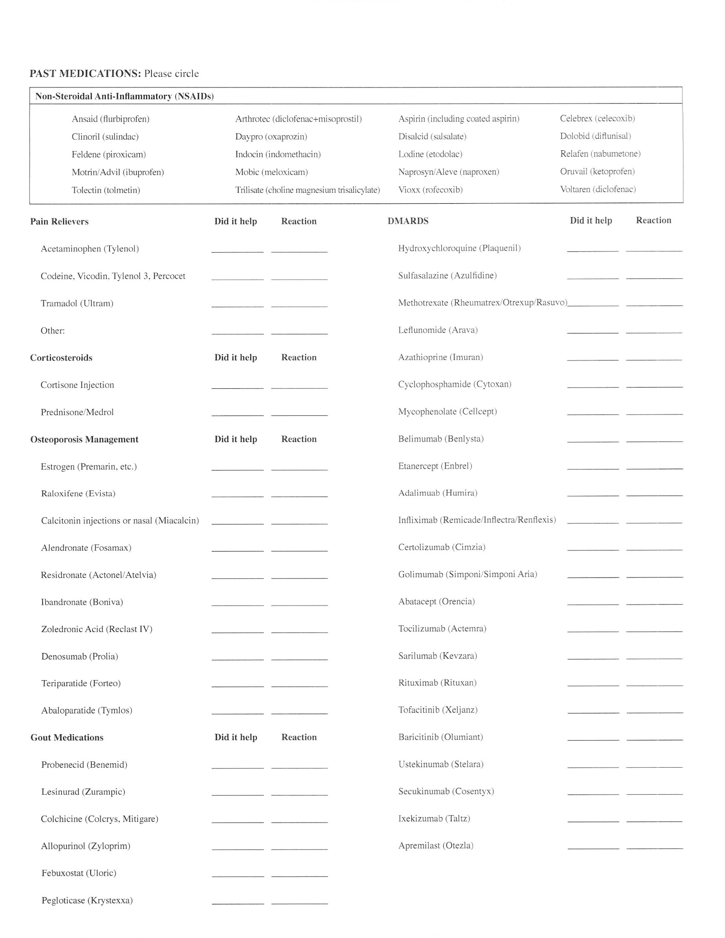

Please review the following list and check/circle any of these problems which have significantly affected you.
GENERAL STOMACH SKIN
Recent weight gain Nausea Rash
Amount ______ Vomiting of blood or coffee ground material Hives
Recent weight loss Stomach pain relieved by food/ milk Sun Sensitivity
Amount _______ Jaundice Tightness
Fatigue Constipation Nodules
Night Sweats Diarrhea Hair Loss
Fever Blood in Stool Color changes of hands/feet in the cold
EYE Black stool NEUROLOGICAL SYSTEM
Pain Heartburn Headaches
Redness KIDNEY/URINE/BLADDER Dizziness
Loss of vision Blood in urine Fainting/ passing out
Double/ blurred vision Genital Rash Weakness
Dryness Genital Ulcers Numbness/ Tingling/ Burning
Itching eyes MUSCLES/JOINTS/BONES Trouble with sleep
EARS-NOSE-MOUTH-THROAT Morning stiffness, Memory Loss
Nosebleeds If so, how long does it last Anxiety
Dryness in nose _____Minutes ____ Hours Depression
Bleeding Gums Joint Pain BLOOD/ LYMPH NODES
Sores in Mouth Muscle Weakness Swollen Glands
Dryness of Mouth Muscle Tenderness Tender Glands
Hoarseness Joint Swelling Anemia
Difficulty in swallowing List joints affected in the last 6 months Bleeding Tendency
Jaw Pain ________________________________ Transfusion/ When ______
HEART _____________________________ Blood Clots/ DVT/ PE
Pain in chest _____________________________ FOR WOMEN ONLY:
Irregular Heart Beat/ Palpitations ________________________________ Age when periods began: _____
Heart Murmurs ________________________________ Date of last period: __________
LUNGS Bleeding after menopause? Y N
Shortness of breath Number of Pregnancies? ______
Swollen legs/feet Number of Miscarriages? ______
Cough / coughing blood
Wheezing
DIRECTIONS TO 816 GREENBRIER CIRCLE, SUITE A CHESAPEAKE, VA 23320 PHONE (757) 461-3400
FROM NORFOLK/ VIRGINIA BEACH: Take I-64 East to the Greenbrier Parkway North Exit. Turn right onto Woodlake Drive and continue straight (WAWA gas station on the left). Go straight across at the stop light, Woodlake Drive becomes Greenbrier Circle. As you continue on Greenbrier Circle there will be a Cedar Tree Inn and Extended Stay America Motel on the right. When you see the main entrance to the Wingate Hotel, turn left into Greenbrier Tech Center II. This is 816 Greenbrier Circle. The Center for Arthritis is located in Suite A at the end of the entrance road.
From Great Bridge/ North Carolina: Take I-64 West to the Greenbrier Parkway North Exit. Turn right onto Woodlake Drive and continue straight (WAWA gas station on the left. Go straight across at the stop light, Woodlake Drive becomes Greenbrier Circle. As you continue on Greenbrier Circle there will be a Cedar Tree Inn and Extended Stay America Motel on the right. When you see the main entrance to the Wingate Hotel, turn left into Greenbrier Tech Center II. This is 816 Greenbrier Circle. The Center for Arthritis is located in Suite A at the end of the entrance road.
From North Military Highway: Take Military Highway South to Old Greenbrier Road. Turn Left on Old Greenbrier and turn Left on to Woodlake Drive. Woodlake Drive becomes Greenbrier Circle. As you continue on Greenbrier Circle there will be a Cedar Tree Inn and Extended Stay America Motel on the right. When you see the main entrance to the Wingate Hotel, turn left into Greenbrier Tech Center II. This is 816 Greenbrier Circle. The Center for Arthritis is located in Suite A at the end of the entrance road.
From South Military Highway: Take Military Highway North to Greenbrier Parkway. Turn Right onto Greenbrier Parkway. Turn Left at Woodlake Drive and continue straight. (WAWA gas station on the left). Go straight across at the stop light, Woodlake Drive becomes Greenbrier Circle. As you continue on Greenbrier Circle there will be a Cedar Tree Inn and Extended Stay America Motel on the right. When you see the main entrance to the Wingate Hotel, turn left into Greenbrier Tech Center II. This is 816 Greenbrier Circle. The Center for Arthritis is located in Suite A at the end of the entrance road.
From Kempsville Road/ Volvo Parkway: Take Greenbrier Parkway North to Woodlake Drive. Turn Right onto Woodlake Drive and continue straight (WAWA gas station on the left). Go straight across at the stop light, Woodlake Drive becomes Greenbrier Circle. As you continue on Greenbrier Circle there will be a Cedar Tree Inn and Extended Stay America Motel on the right. When you see the main entrance to the Wingate Hotel, turn left into Greenbrier Tech Center II. This is 816 Greenbrier Circle. The Center for Arthritis is located in Suite A at the end of the entrance road.

DIRECTIONS TO 1033 CHAMPIONS WAY, SUITE 100 SUFFOLK, VA 23435 PHONE (757) 483-2783
Directions from I-664: Take exit 9A (James River Bridge exit). Merge onto US-17 North/Bridge Road. Turn right at the first light onto Harbour View Blvd. Go to the 3rd traffic light, turn left onto Champions Way. 1033 Champions Way will be on your left. If you have reached Konikoff Dentistry, you have gone too far.

